Rishi Sharma

Class deliverables

IT 520

1. [74.96.240.218](https://whatismyipaddress.com/ip/74.96.240.218)

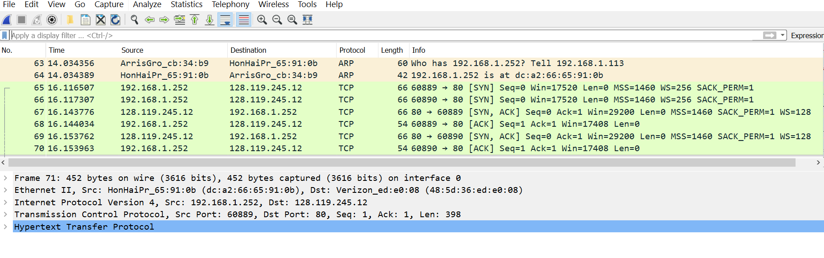

1. It took 2 seconds  
   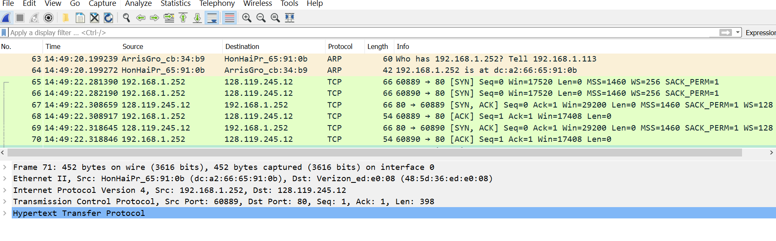
2. 128.119.245.12

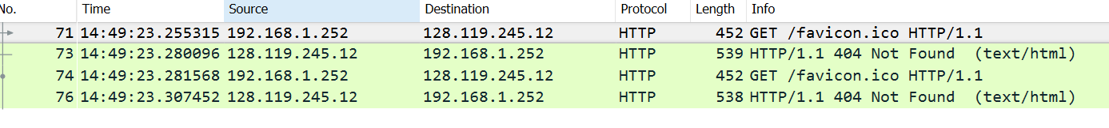

1. See next page